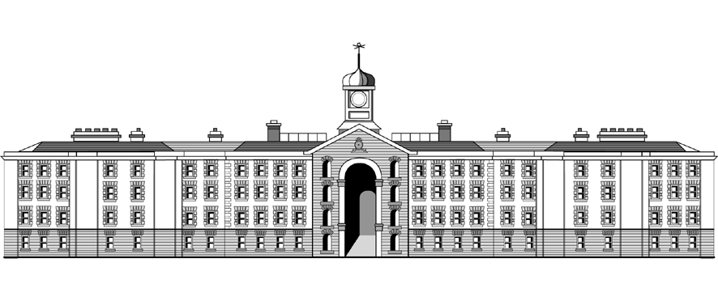

**Griffith College Limerick**

**COMPUTING LAB TITLE SHEET**

**Course:** B.Sc. in Computing (Level 7 and Level 8)

**Stage/Year:** II

**Module:** Object-Oriented Programming

**Semester:** I

**Lab Number:** II

**Date of Title Issue:** 3/10/23

**Assignment Deadline: 17/10/23 22:59**

**Assignment Submission:** Submitted on Moodle

**Assignment Weighting:** **10%**

## Assignment Two (Lab 02)

|  |  |
| --- | --- |
| **Create a project called LabTwo_StudentNumber**  With StudentNumber being your student number i.e LabTwo_32323  **Add your student name and id as a comment at the top of each file.**  **Part One**  Create a set of classes for an Eircode map application (https://www.eircode.ie/what-is-eircode). For each class make all attributes private and add getters and setters.  Create a file **Map.java** with a main method, use this class to create and test your objects.      **Part Two**      Note: while you **cannot** add extra methods to the instance classes you can create any extra methods you want in Map.java to complete the menu tasks.  **20% of marks are for comments and coding standards**   * Add a comment with your name and ID at the top of the files. * Use lowercase for variable names. * Use uppercase for class names. * Use the given names for attributes and methods. * Keep each class/interface in a separate .java file. * Keep all attributes private unless otherwise stated. * Comment any behaviours you added. * Do not create any unneccesary duplicate methods, (i.e. There should be no getAddress in **ResidentialBuilding** as it already inherits it from **Building)**   **Zip the whole project folder and upload your folder as LabTwo_StudentNumber.zip**   |  | | --- | |  | |
|  |